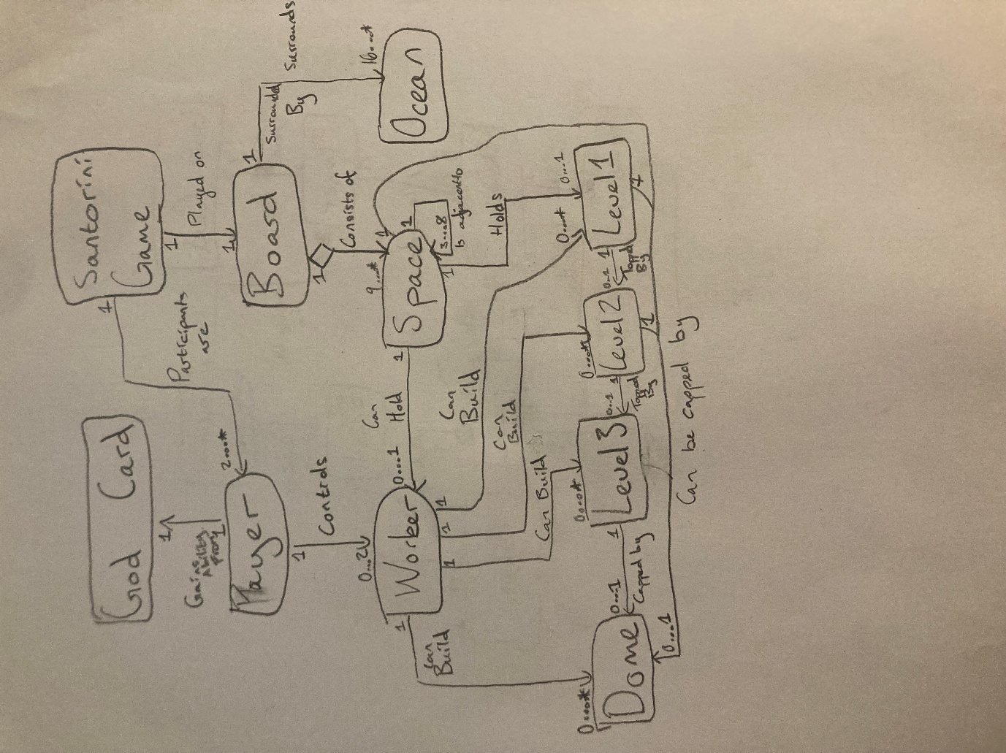

Entities:

* Santorini Game:

This entity is the overall game experience. Players participate in the game, and the entire game is played on the board, of which only one board can be played on one game. At a minimum, 2 players are needed to play, but the game can be extended to allow in theory an infinite number of players.

* God Card:

The god card is the entity representing the different god abilities present in the game. Like how in a physical copy of the game, where the player holds the one and only copy of a god, and this is the only god card they hold, represented by the 1-1 relationship.

* Player:  
  The player is directly responsible for their own workers, and using their god ability, represented by their associations. The player should always have a maximum of 2 workers, however if they play against the goddess Bia, they can possibly have their workers killed, meaning that they would lose them, as seen in the possibility of holding 0 to 2.
* Board:

Since a game board is really just a collection of spaces, arranged in a grid, I have represented this relationship as being an aggregation relationship. The multiplicity of 0 to Many is important, we can have a dynamic amount of tiles depending on the, given that an extension to be implemented are dynamically sized maps.

* Space:

The empty position at some point in the map. Each space represents some 2D position within the boards grid. This entity exists since different rules specifically request checking different empty / occupied spaces. Space can hold a wide variety of pieces, and every piece can only exist within 1 space. Spaces should be aware of their adjacencies, in order to dictate where workers can move and where a worker can build, as shown by the cyclical association. At a minimum, a corner space will have three adjacencies, and a centre space will have eight.

* Ocean:

The ocean is the ring of untraversable space on the perimeter of the board. It exists in the board as a more symbolic representation to the end of the board, but it can exist within our implementation as a more practical tile barrier. Assuming a minimum board map of 3x3, the minimum amount of ocean tiles is 16, and that the board can be in theory infinite size, this relation thus is 16 to Many.

* Worker:  
  Each worker has only 1 player that is responsible for giving it moves. Workers are responsible for building different building blocks. Each space can only have 1 worker on it. Workers can build as many buildings as possible, or none at all, and every type of building, as is shown in the 0 to many relationship.
* Levels:

Each building block needs to exist on 1 space, and can be built by 1 worker. However, each space can hold no buildings, to a maximum of 3 building blocks. Buildings also are broken up into 3 layers, of which layer 1 must be built on an empty space, layer 2 must be built on layer 1, layer 3 must be built on layer 2, with each of these relationships being designated a 1 to 0…1 relationship to highlight this hierarchy. The distinction of layers are important, since standing on layer 3 triggers a win condition, building on layer 3 makes a dome, and certain gods have interactions tied to specific layers (E.g, Eros wins on layer 1).

* Dome:

This entity is separate to the building, as it has very different functionality (blocking workers from moving, where building allows traversal). Another thing of note is that all rule specifications referring to buildings do not include domes, which means specific god abilities that refer to buildings only affect buildings (e.g, Ares can destroy building tiles, but not domes). Domes can also be built without buildings, or straight on the ground (Selene god ability), so as such it holds a 0 to 1 relationship with them. There can only be 1 dome maximum per space, which is why it has a 0 to 1 multiplicity.